Use-Case Realization Report (Design)
View Outline

Issue <1.0>
Revision History
Date | Issue | Description | Author
29/11/09 | 1.0 | Initial Version | Rajendran Kumaraguru

Table of Contents
1. Brief Description 4
2. Flow of Events 4
2.1 Standard Flow 4
2.2 Exception Flow 4
3. Interaction Diagrams 5
3.1 Sequence Diagram for ViewOutline 5
4. Participating Objects 6
5. Class Diagrams 6
5.1 Class Diagram for ViewOutline 6
6. Derived Requirements 6

Use-Case Realization Report
View Outline

Brief Description
Portal admin will be able to view the existing outlines which are already created for different companies.

Flow of Events

Standard Flow
- Portal Admin login into the system.
- Portal admin clicks btnViewOutline()
- System loads outline Details
- System gets all outline details
- Validate the input fields data.
- Get the outline information from the entity
- Show the created outline detail to portal admin.

Exception Flow
  - If there is any error while validating the data then the respective exception will be thrown to portal admin.
  - If there is such outline exist then the error message will shown to portal admin.

Interaction Diagrams

Sequence Diagram for ViewOutline
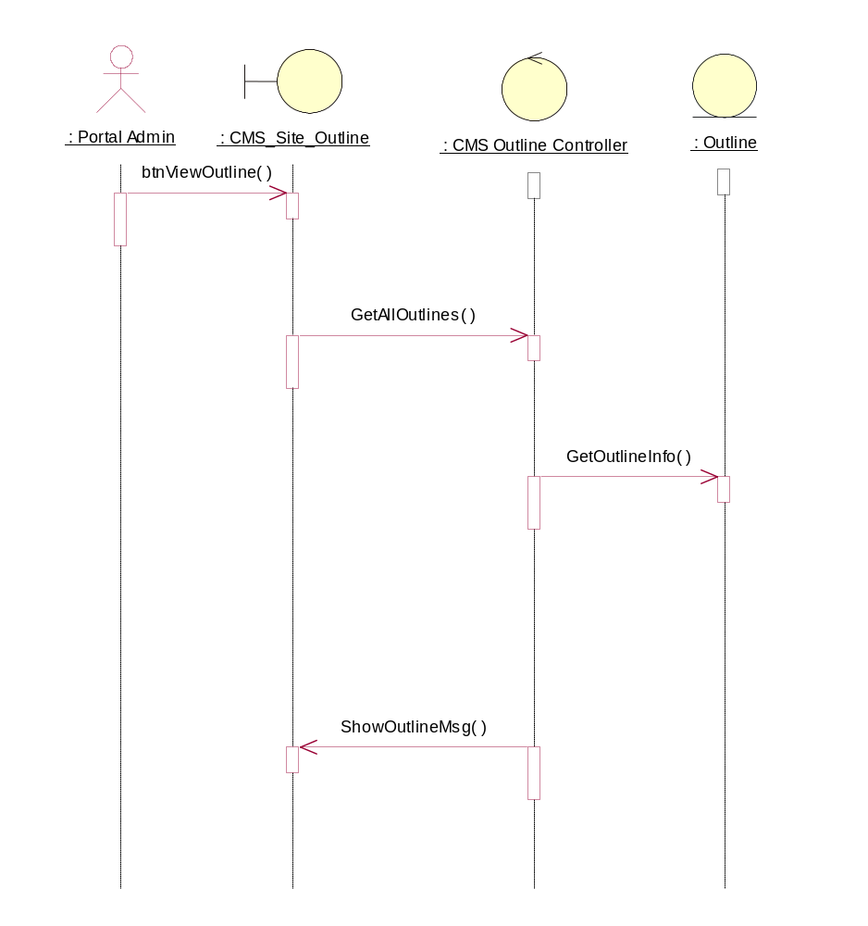

Participating Objects
: CMS Outline Controller

: CMS_Site_Outline

: Outline

: Portal Admin

Class Diagrams

Class Diagram for ViewOutline
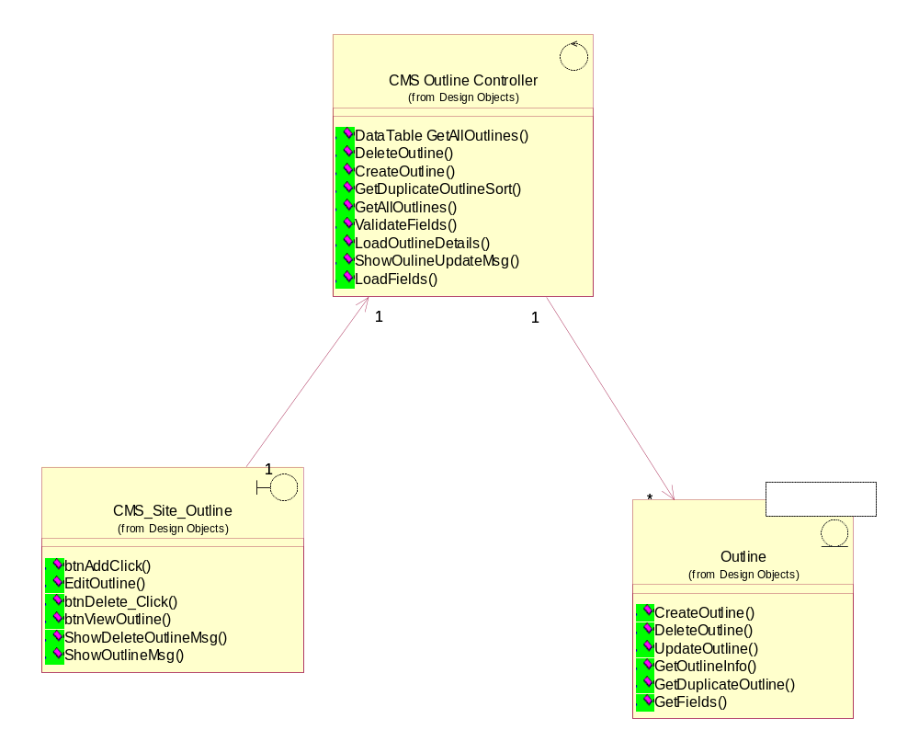

Derived Requirements
[enter the derived requirements here]

